Guide
Voy a tener 2 vistas, una común para poner el zip code, que va a estar en la principal no en la PDP, y una segunda que va a estar asociada a la PDP (ver código de the Jeske que ahí se agregaba una vista a la PDP).

First child view
En Main.js agrego una vista con addChildView que adentro tendra “Your zip: Enter a US Zip code” message and a pop up view.
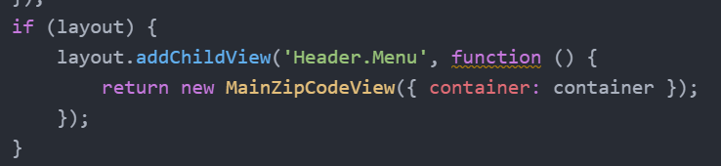

Dentro de esta view entonces, tenemos el botón de enter zip code y debajo la sección del pop up. La sección del pop up solo será visible cuando se presiona el botón. Usamos el handler del botón que va a hacer un toggle de la clase para quitarla o agregarla.
Creamos una nueva vista y su template, en el template agregamos el botón y el pop up.
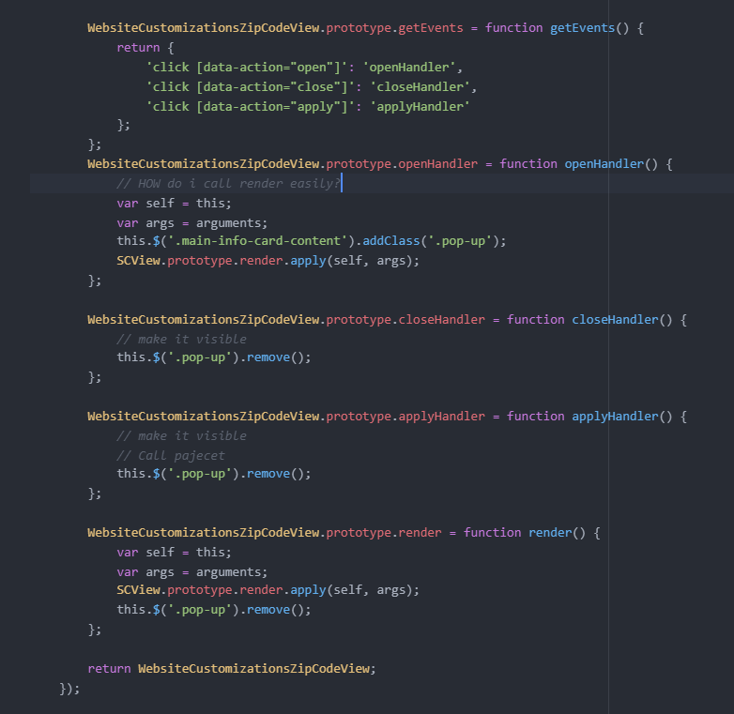
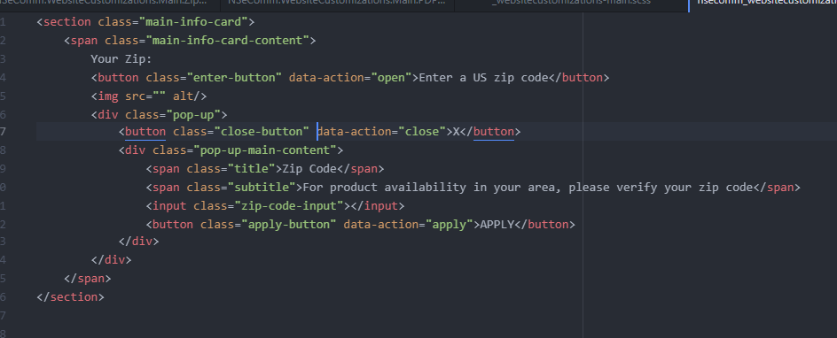

Llamamos al PDP y agregamos algo ahí, como hicimos con the Jeske company.

How to add this pop up?

A new child view for pajecet.
Having a child view at the header, on there we will handle the zip code.
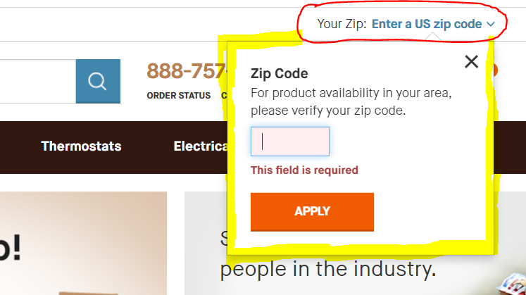
Since it’s a child view, we can add our own method to store that zip code into a session variable.
When it gets after show content on the pdp we get that zip code, we call pajecet and that’s it.

Second child View
Creamos una nueva vista que sea una SC view, va a tener su propio template con la forma de la imagen de abajo, y la vamos a agregar al PDP con add child view como hicimos en Jeske:
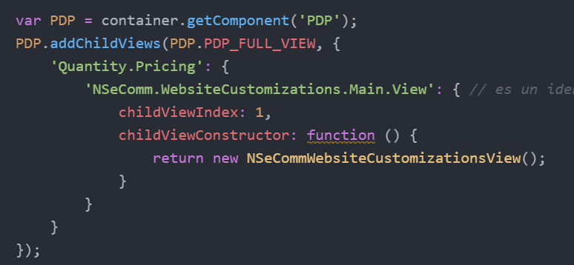
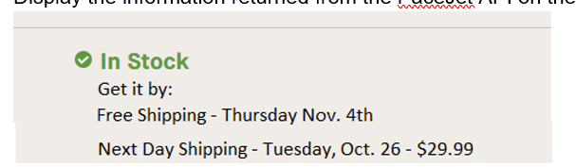
Esta información la va a devolver la pajecet API.

Another child view to display the information returned from the pajecet API on the product detail page. Using the PDP Component, we can have the selected matrix childs, getSelectedMatrixChild.

You land on the homepage, on the header put your zip code. The header will appear everywhere. That won’t do anything until you get to a PDP.
Add a view on the product details page. Attach a handler to “Apply” button, then call the service.
If then you navigate to a PDP, once you click on the apply zip code, we call this pajecet, this information about next day shipping and everything.
Let say you have matrix items (it’s items with options) and you have to choose options, maybe an item ships cheaper when it’s smaller.
Second customization:
Netsuite only allows to submit orders if it’s following the checkout process.
Paypal button, this is not doable at all, they need to go to the checkout process in order to buy something. Paypal is already integrated with the product, and it does not support buying from the product page.

We should follow all the steps to actually buy with paypal, not like this simple. It has nothing to do with NetSuite.
The problem is not actually going to the site to fill the whole information, the problem is how the information comes back to netsuite to fill the correct fields.

Vamos a agregar un botón, y te va a llevar a paypal y ya esta, te tiene que avisar por mail que compraste.
var zipCode = this.$('#zipcode').val();

this.$('.pop-up').hide();

